**Lampiran**

1. Data Latih

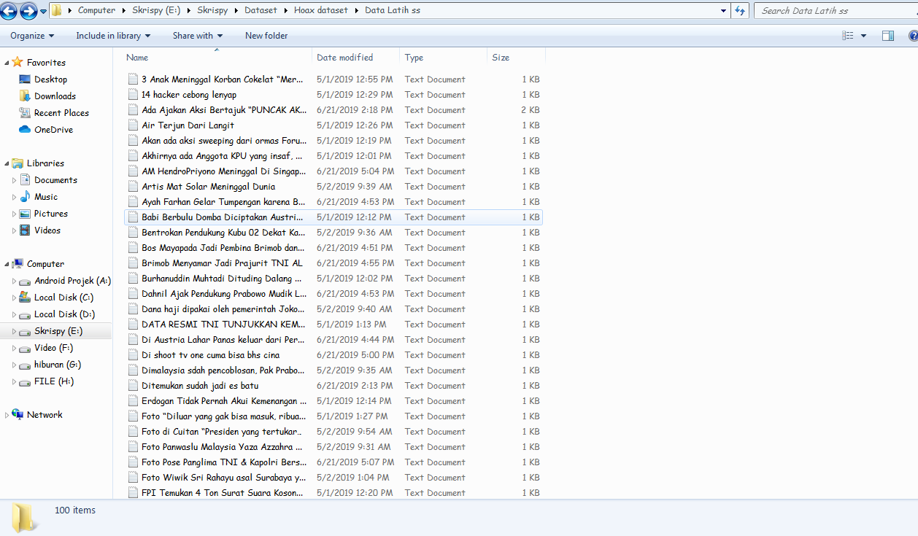

1. Data Uji

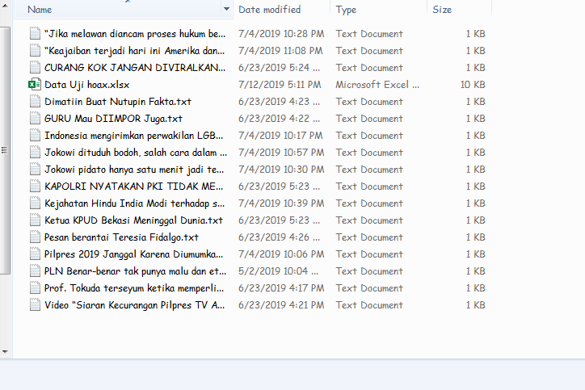

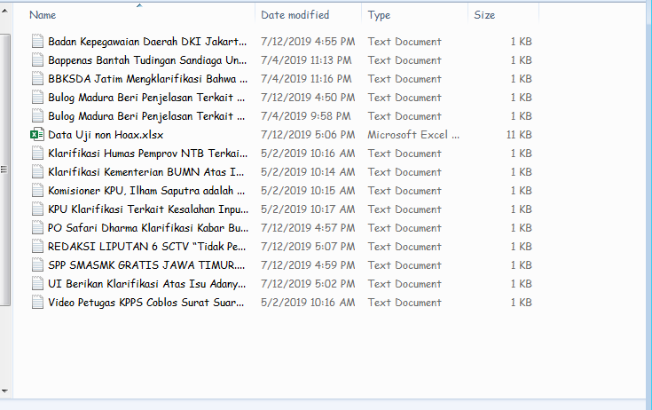

1. Nilai Limit

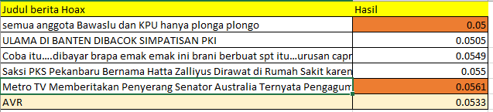

1. Nilai Uji *Hoax*

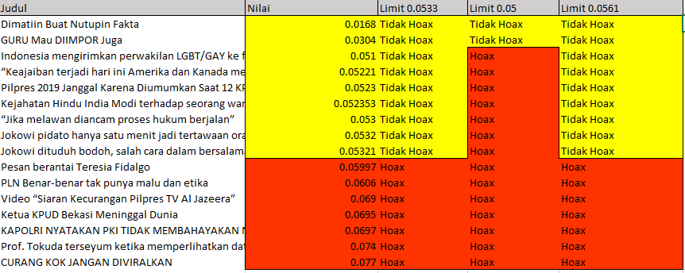

1. Nilai Uji *Real*

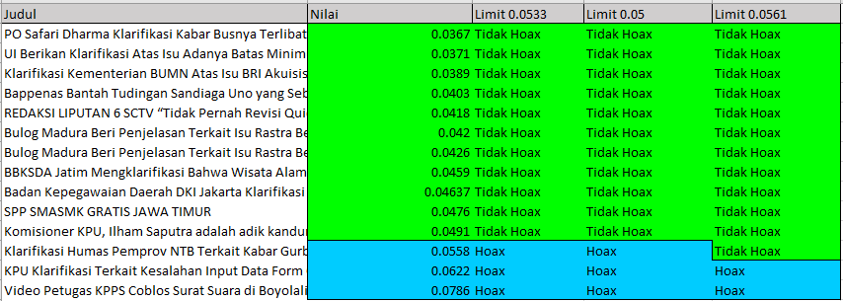

1. Script Main.py

|  |
| --- |
| import tkinter  import db_Berita as dbs  import Nlp as nlp  import SumberInput as si  window = tkinter.Tk()  window.title('Deteksi Berita Hoax')  window.geometry("1000x600")  #Input ke Database  def db():  window3=tkinter.Tk()  window3.geometry("800x400")  window3.title('Input Database')  #GUI  LabelInput = tkinter.Label(window3, text="Nama Berita ")  TextInput = tkinter.Text(window3, height=2, width=50)  LabelInput1 = tkinter.Label(window3,text="Inputkan Berita")  TextInput1 = tkinter.Text(window3,height=10, width=70)  # ambil isi masukkan db  def get():  input=TextInput1.get("1.0", "end-1c")  input=nlp.Neuralp(input)  lang=len(input.split())  #print(nlp.Neuralp(input))  #print(len(nlp.Neuralp(input)))  #input into db  dbs.database(TextInput.get("1.0", "end-1c"), input,lang)  #popup  windowpop = tkinter.Tk()  windowpop.geometry("250x50")  windowpop.title('Database')  LabelInputpop = tkinter.Label(windowpop, text="Berita Berhasil Di Inputkan")  LabelInputpop.pack()  #library kata  #lib.library()  #JudulBerita = TextInput.get("1.0", "end-1c")  #print(JudulBerita)  #Berita = TextInput1.get("1.0", "end-1c")  #print(Berita)  buttonok = tkinter.Button(window3,text='Tambahkan Ke Database',command=get,height=5,width=18)  #run  LabelInput.pack()  TextInput.pack()  LabelInput1.pack()  TextInput1.pack()  buttonok.pack()  #Input Data Uji  def input():  inp = TextInput.get("1.0", "end-1c")  inpjdl = Jdl.get("1.0", "end-1c")  #steming dan pencocokan library  sumber=si.Sumber(inp)  Hasil=si.hitung(sumber)  #new pop up  window2=tkinter.Tk()  window2.title('Input Data')  window2.geometry("500x300")  Labeljdl=tkinter.Label(window2, text="Judul Berita : ")  LabelInput2 = tkinter.Label(window2, text="Nilai : ")  LabelInput3 = tkinter.Label(window2, text="Hasil Deteksi : ")  Labeljdl.pack(pady=10)  #judul  LabelInputjdl = tkinter.Label(window2, text=inpjdl)  LabelInputjdl.pack(pady=10)  #Nilai  LabelInput2.pack(pady=10)  LabelInput = tkinter.Label(window2, text=Hasil)  LabelInput.pack(pady=10)  #Hasil deteksi  LabelInput3.pack(pady=10)  #Limit  #print (Hasil)  #Klasifikasi  if(Hasil > 0.05):#limit (rataan library)  LabelInput = tkinter.Label(window2, text='TerIndikasi HOAX',fg='red')  LabelInput.pack(pady=30)  else:  LabelInput = tkinter.Label(window2, text='Tidak Hoax', fg='blue')  LabelInput.pack(pady=30)  window2.mainloop()  #main window  button_input = tkinter.Button(window,text='Input Berita',command=input,height=5,width=18)  button_input2 = tkinter.Button(window,text='Tambah Database',command=db,height=5,width=18)  LabelInput=tkinter.Label(text="Inputkan Berita")  TextInput = tkinter.Text(height=10, width=70)  LabelInput2=tkinter.Label(text="Inputkan Judul")  Jdl = tkinter.Text(height=2, width=70)  LabelInput2.pack(pady=20)  Jdl.pack()  LabelInput.pack(pady=20)  TextInput.pack()  button_input.pack(pady=20)  button_input2.pack()  # Positions the window in the center of the page.  window.geometry("+{}+{}".format(90, 50))  window.mainloop() |

1. Script SumberInput.py

|  |
| --- |
| import Nlp  import openpyxl  #Proses Input data Uji  def Sumber(text):  g=Nlp.Neuralp(text)  return g  #uji Inputan  #text='Halo Susu dunia.. Hai('  #Hasilnlp=Sumber(text)  #print(Hasilnlp)  def hitung(text):  #pembandingan dengan librari  nlpcount=0  text=text.split()  jmlkata=len(text)  sigmakatasama=0  #print(jmlkata)  for g in text:  wk = openpyxl.load_workbook("kata.xlsx") #ganti  sh = wk.active  rows = sh.max_row  for i in range(1, rows + 1):  c = sh.cell(i,1)  h=sh.cell(i,4)  #print(c.value)  if(text[nlpcount]==c.value):  sigmakatasama+=h.value  # print(c.value,h.value,Hasilnlp[nlpcount])  nlpcount+=1  print(sigmakatasama,jmlkata)  ratahasil=sigmakatasama/jmlkata  return ratahasil  #print(hitung(Hasilnlp)) |

1. Script LibraryKata.py

|  |
| --- |
| import pymysql  import math  import openpyxl  #pembuatan librari kata  def library ():  count=0  loading=0;  Kata=[]  # Open database connection  db = pymysql.connect("localhost", "xiinlaw", "Arcasevenvold04", "skripsi")  # prepare a cursor object using cursor() method  cursor = db.cursor()  # Prepare SQL query to INSERT a record into the database.  sql = "SELECT * FROM berita " #ganti  try:  # Execute the SQL command  cursor.execute(sql)  # Fetch all the rows in a list of lists.  results = cursor.fetchall()  roww = 2  for row in results:  berita = row[2]  #tokenizing  berita=berita.split()  #proses pencarian atribut  r = 0;  loading+=1  print((loading/50)*100," %")  #perulangan indexing kata  for g in berita:  print('Jumlah perulangan :',count)  count+=1  if (berita[r] in Kata):  print('skip')  r+=1  else :  Tf = berita.count(berita[r]) / len(berita)  # idf dan apriori  #jumlah dokumen yang mengandung kata  sqli = "SELECT ID FROM berita WHERE Berita LIKE %s" #ganti  b = berita[r]  a = ('%' + b + '%')  val = (a)  cursor.execute(sqli, val)  a = cursor.fetchall()  rr = len(a)  rr=float(rr)  Kata.append(berita[r])  # print('Kata ke : ',r)  # print(berita[r],' Jmlh :',rr)  Idf = math.log(100 / rr)  apriori = rr/100  TfIdf=Tf*Idf  # print('IDF : ',Idf,' apriori : ',apriori,'TF IDF : ',TfIdf)  # Save on Excel  wk = openpyxl.load_workbook("kata.xlsx") #ganti  sh=wk['kata']  # input kata on excel  kata = sh.cell(column=1, row=roww)  kata.value = berita[r]  # Weight  weight = sh.cell(column=2, row=roww)  weight.value = TfIdf  # Support  supp = sh.cell(column=3, row=roww)  supp.value = apriori  # Hasil  hasil = sh.cell(column=4, row=roww)  hasil.value = (apriori+TfIdf)/2  print('Jumlah Kata Yang tersimpan : ', roww-1)  r += 1  roww += 1  wk.save('uji.xlsx') #ganti  except:  print("Error: unable to fetch data")  # menutup koneksi ke server  db.close()  #run Library  #library() |

1. Script Nlp.py

|  |
| --- |
| import nltk  from Sastrawi.Stemmer.StemmerFactory import StemmerFactory  from Sastrawi.StopWordRemover.StopWordRemoverFactory import StopWordRemoverFactory  import string  #NLP  def Neuralp(text):  #Case Folding /Huruf Kecil  text =text.casefold()  #Stopword Removal / Menghilangkan kata tidak penting  factory = StopWordRemoverFactory()  stopword = factory.create_stop_word_remover()  text = stopword.remove(text)  #Steeming kata dasar  factory = StemmerFactory()  stemmer = factory.create_stemmer()  text=stemmer.stem(text)  #penghilangan tanda baca  text=text.translate(str.maketrans('','',string.punctuation))  #Tokenizing = memecah menjadi kata  #text=text.split()  # Count List/Mencari Jumlah kata dalam satu berita  # r = 0;  #for g in text:  # print(g, ' : ', text.count(text[r]), ', ')  # r += 1  #print('Text : ', text)  #print('=' * 100)  #print('Banyak Total Kata : ',len(text))  return text |

1. Script Update Berita Nlp.py

|  |
| --- |
| #!/usr/bin/python  import Nlp  import pymysql  #update isi berita into NLP isi berita  # Open database connection  db = pymysql.connect("localhost","xiinlaw","Arcasevenvold04","skripsi" )  # prepare a cursor object using cursor() method  cursor = db.cursor()  try:  # Execute the SQL command  for q in range(1,100):  cursor.execute("SELECT Berita FROM berita WHERE ID='%s'" ,(q))  #NLP  a=cursor.fetchall()  a=Nlp.Neuralp(str(a))  print(q)  #update  sql1 = "UPDATE berita SET Berita= %s WHERE ID= %s"  val1 = (a,q)  cursor.execute(sql1,val1)  # Commit your changes in the database  db.commit()  except:  # Rollback in case there is any error  db.rollback()  # disconnect from server  db.close() |

1. Script Db_Berita.py

|  |
| --- |
| #!/usr/bin/python  import Nlp  import pymysql  #update isi berita into NLP isi berita  # Open database connection  db = pymysql.connect("localhost","xiinlaw","Arcasevenvold04","skripsi" )  # prepare a cursor object using cursor() method  cursor = db.cursor()  try:  # Execute the SQL command  for q in range(1,100):  cursor.execute("SELECT Berita FROM berita WHERE ID='%s'" ,(q))  #NLP  a=cursor.fetchall()  a=Nlp.Neuralp(str(a))  print(q)  #update  sql1 = "UPDATE berita SET Berita= %s WHERE ID= %s"  val1 = (a,q)  cursor.execute(sql1,val1)  # Commit your changes in the database  db.commit()  except:  # Rollback in case there is any error  db.rollback()  # disconnect from server  db.close() |